VEX IQ Level Up : Session 2 - Game Station

Activity: Dive into the VEX IQ Level Up competition, gameplay, and scoring.
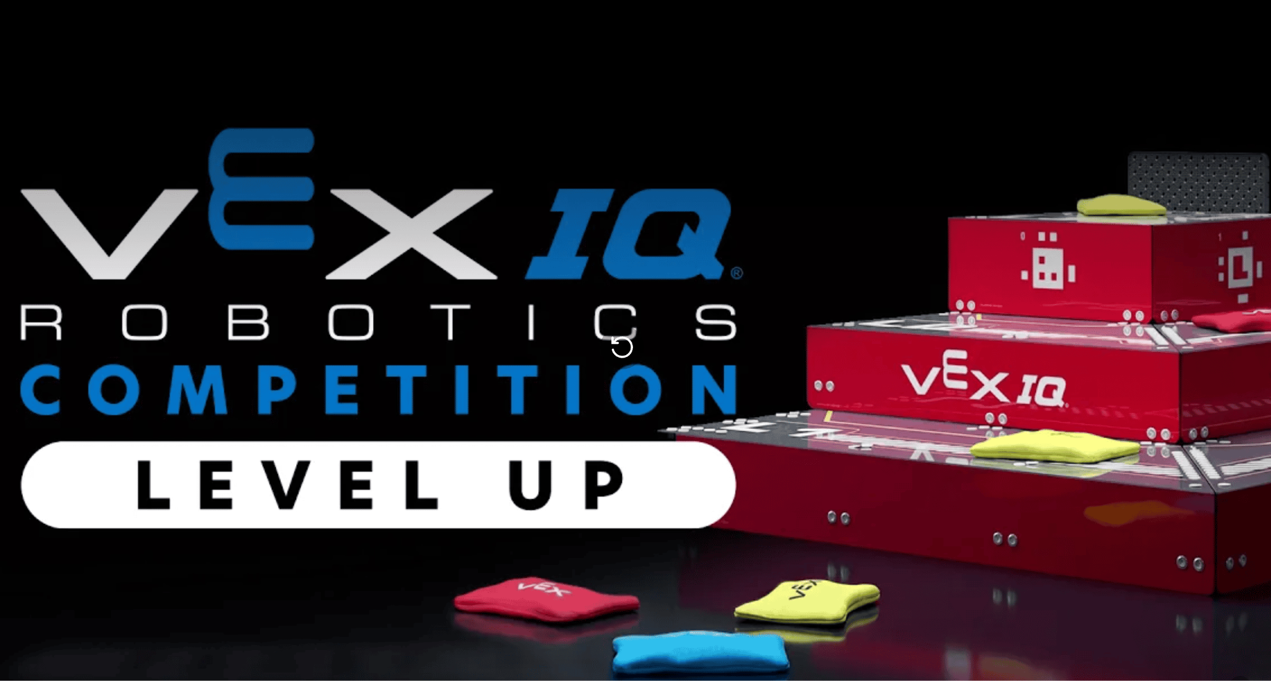
- Watch the reveal video about Level Up.
- Choose at least three of the questions below.
  - First, answer them in your engineering notebook
  - Next, share your answers with your partner to help you think more about the competition.

    - What do I know about this competition?
    - What questions do I have about the rules or the game setup?
    - What do I need to consider about my robot design or coding strategy in relation to the rules of the competition?
    - How can I find the answers to questions I have about the competition?
    - What are some initial steps I can take towards developing a strategy for the competition?
    - Who can help me with a challenge if I get stuck? How can they help?

Pro Tips:
- Record answers to your questions in your own words. This will help you to build your understanding of the rules and the game.
  - Use images or sketches to help illustrate your answers.
- Use the VEX IQ Level Up Game Manual to help answer questions.
Feeling Stuck?
- Talk with your team members or Coach, and ask questions that are specific and clear.

Discussion Questions  - What part of the game are you most excited about? Why?  - What part of the game do you think your partner team will focus on? (Scoring in Floor Goals, on Pyramid Goals, etc.) Why? | Activity Checklist  - Each team member watched the game video.  - Each team member answered at least 3 questions.  - All questions were documented in the engineering notebook.

